1. Introduction
1.1 Background
Computer networks have become essential infrastructure for educational institutions. Universities rely on network systems to provide internet access, learning management systems, administrative services, digital libraries, research platforms, and communication services.
Hawassa University Main Campus contains more than twenty interconnected buildings that support teaching, research, administration, and student services. To maintain effective communication among these facilities, a campus-wide network infrastructure has been deployed.
This project focuses on assessing the existing network infrastructure of the university and proposing improvements for the Lab Building network environment.
1.2 Objective
General Objective
To study the existing network infrastructure of Hawassa University Main Campus, identify limitations, and propose an enhanced network design for the Lab Building.
Specific Objectives
- Assess the existing campus network.
- Study the network infrastructure of the Lab Building.
- Identify network performance and security gaps.
- Evaluate current network devices and topology.
- Propose network enhancements.
- Improve wireless coverage and scalability.
- Strengthen network security and management.
1.3 Scope
The project focuses on one selected building (Lab Building) among the more than twenty buildings connected within the Hawassa University Main Campus network.

2. Existing Network Assessment
2.1 General Network Overview
The Hawassa University Main Campus network is a hybrid network connecting academic, laboratory, and administrative buildings. The network provides access to university resources, internet services, and communication systems.
The campus network connects more than twenty buildings through a hierarchical architecture consisting of a core router, distribution switches, and access switches.
2.2 Existing Network Topology
The campus network follows a hybrid topology composed of:
- Ring topology
- star topology
The ring structure improves connectivity among major buildings while the star structure provides efficient resource sharing across the campus network.
The network follows a hierarchical model including:
Core Layer
- One Core Router
Distribution Layer
- Two Distribution Switches
Access Layer
- Building-level access switches
2.3 Network Infrastructure
The university uses structured cabling infrastructure including:
- Fiber optic backbone connections between buildings
- UTP cabling within buildings
- Network cabinets and communication rooms
- Patch panels and switching infrastructure

2.4 Network Devices
The following devices are commonly deployed:
- Routers
- Distribution Switches
- Access Switches
- Wireless Access Points
- CCTV Cameras
2.5 Internet and Bandwidth
The university network provides internet access to students, staff, instructors, and administrative personnel.
Although internet connectivity is available across campus, bandwidth utilization increases significantly during peak hours when students access online learning platforms and research resources.
2.6 Wireless Network Assessment
Wireless connectivity is available in selected areas.
Observation from the Lab Building indicates that:
- Only one wireless access point exists on the second floor.
- Other floors rely mainly on wired connectivity.
- Wireless coverage may not be sufficient for future expansion.
2.7 IP Addressing and Management
The campus uses IP addressing to identify devices and provide communication between departments and buildings.
Network management is performed centrally through the campus network infrastructure.
2.8 Network Security Assessment
Current security mechanisms include:
- Router-based access control
- Device authentication
- Physical security controls
However, additional improvements are required to strengthen network segmentation and monitoring.
2.9 Performance and Reliability
The network generally supports campus operations successfully. However, increasing numbers of users and devices create challenges related to:
- Congestion
- Scalability
- Wireless coverage
- Security management

3. Lab Building Network Analysis
3.1 Ground Floor
The ground floor contains administrative offices and support facilities.
Installed equipment:
- CCTV Camera (1)
Purpose:
- Security monitoring
- Building surveillance
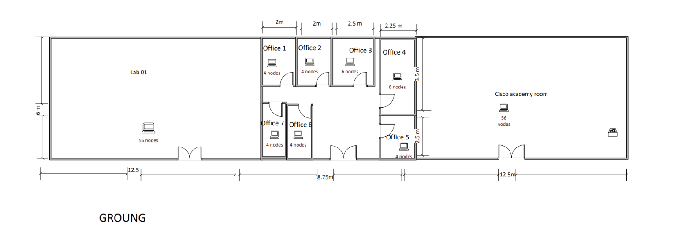
3.2 First Floor
Facilities:
Room | Nodes
Cisco Academy Lab | 56
Lab 2 | 56
Offices | Multiple
Network Equipment:
- Three 48-Port Switches
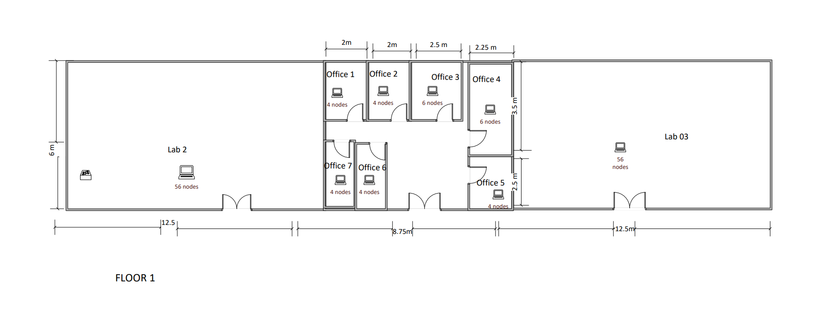
3.3 Second Floor
Facilities:
Room | Nodes
Lab 4 | 56
Lab 5 | 56
Offices | Multiple
Network Equipment:
- Three 48-Port Switches
- One Wireless Access Point
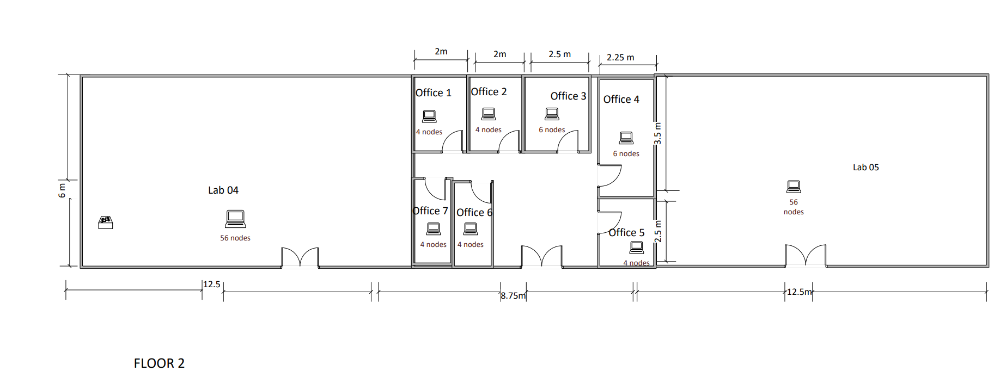
3.4 Third Floor
Facilities:
Room | Nodes
Lab 6 | 56
Lab 7 | 56
Offices | Multiple
Network Equipment:
- Three 48-Port Switches
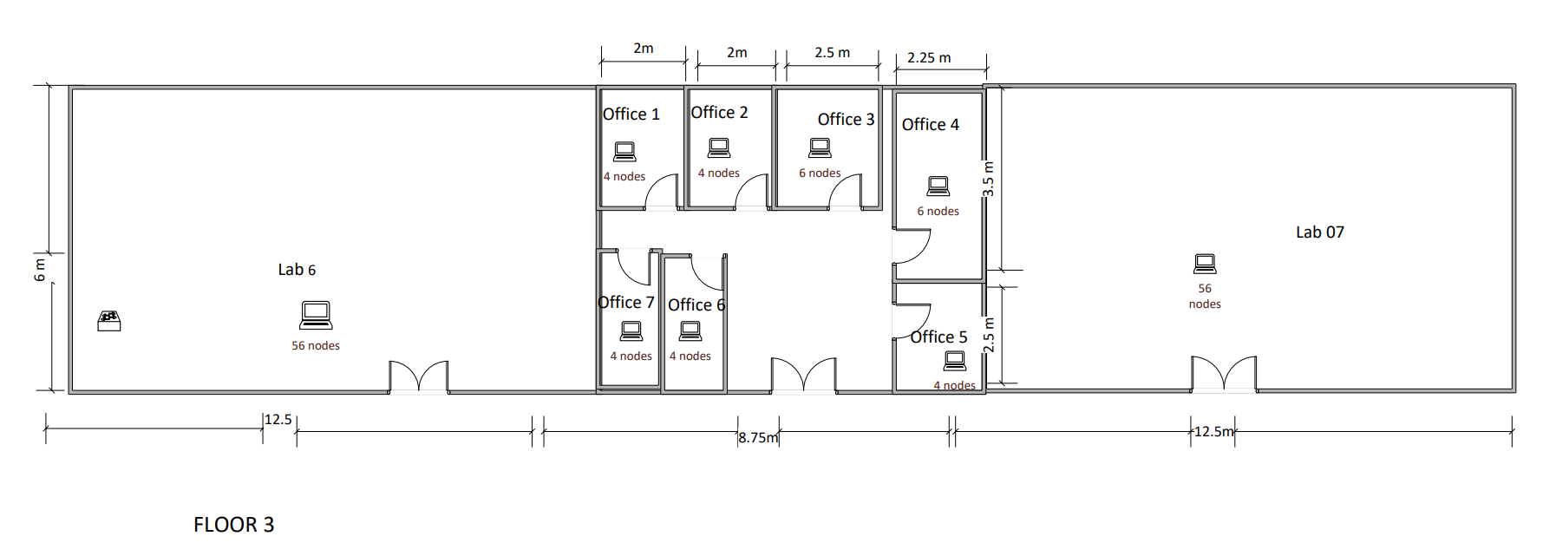
3.5 Logical design
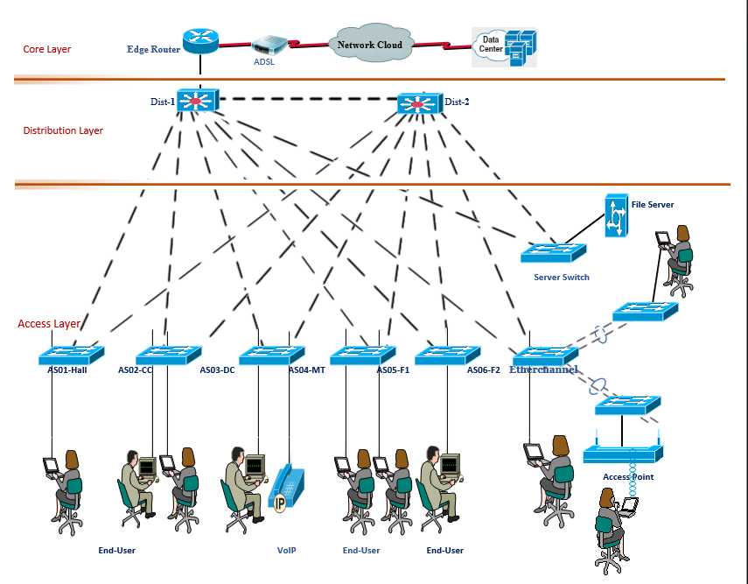

4. Challenges and Limitations
The assessment identified the following limitations:
4.1 Limited Wireless Coverage
Only one access point is available on the second floor.
4.2 Lack of Network Segmentation
Different types of traffic may operate within the same network segment.
4.3 Scalability Issues
Future growth in users and devices may exceed current network capacity.
4.4 Security Concerns
The CCTV system and user devices should be logically separated.
4.5 Monitoring Limitations
Network monitoring and management capabilities can be improved.
4.6 Single Point of Failure
Some connections may not have backup paths.

5. Proposed Network Enhancement
5.1 Wireless Improvement
Deploy additional access points on:
- Ground Floor
- First Floor
- Third Floor
This will ensure complete building-wide wireless coverage.
5.2 VLAN Segmentation
Create separate VLANs for:
- Laboratory Users
- Office Users
- Wireless Users
- CCTV Devices
- Network Management
5.3 Security Enhancement
Implement:
- Access Control Lists (ACLs)
- Port Security
- Strong Authentication
- Device Monitoring
5.4 Infrastructure Enhancement
- Upgrade structured cabling where required.
- Improve cable management.
- Label network ports and devices.
5.5 Network Management
Deploy centralized monitoring tools for:
- Traffic analysis
- Fault detection
- Device management
5.6 Future Expansion Support
The enhanced design should support:
- Additional laboratories
- More wireless users
- Smart classroom technologies
- IoT devices

6. Recommendations
What Should Be Improved?
- Wireless coverage
- Network monitoring
- Security controls
- Scalability planning
What Should Be Replaced?
- Aging network equipment when necessary
- Unstructured cabling segments
What Should Be Added?
- Additional Access Points
- VLAN implementation
- Monitoring systems
- Redundant network paths
- Enhanced security mechanisms

7. Conclusion
The study assessed the existing network infrastructure of Hawassa University Main Campus and focused specifically on the Lab Building. The assessment revealed that the campus network follows a hierarchical architecture with a hybrid ring-bus topology and successfully connects more than twenty buildings. However, several limitations were identified, including limited wireless coverage, scalability concerns, security challenges, and insufficient network segmentation.
To address these issues, an enhanced network design was proposed involving VLAN implementation, improved wireless coverage, stronger security controls, centralized monitoring, and support for future expansion. The proposed improvements will increase network performance, reliability, security, and scalability while providing a stronger foundation for future academic and administrative services.

